Hex Dumbbells, Home & Gym Cast Iron Dumbbells, Rubber Encased Hexagonal Dumbell, 2x7,5 KG, Pair
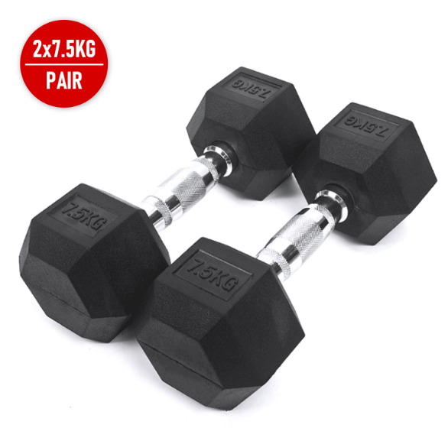

About this item
- TONES & BUILDS muscle size and strength | Perfect for Strength, Power, Speed, Muscle Building and Fat Loss Training and Exercise.
- DESIGNED FOR COMFORT AND DURABILITY | Chrome plated steel with knurled pattern on the handle, Pinned Heads to ensure strength, stability and durability. Ergonomic steel handles for a comfortable grip and hexagonal shape to prevent rolling.
- MAKE YOUR GYM AT HOME | Ideal for home gyms and home workouts, Can be used for full body workouts or for isolation exercises on specific muscle, body parts or movements.
- QUALITY AND SAFETY FIRST | Durable rubber will not crack or fade, and prevents damage to floors and equipment
- CHOOSE YOUR WEIGHT | Available in 2.5kg, 5kg, 7.5kg, 10kg. 12.5kg, 15kg, 17.5kg, 20kg, 22.5kg, 25kg, 27.5kg and 30kg.

Technical Details
Style | ‎Fixed
Material type | ‎Cast Iron
Brand | ‎LMS Data
Manufacturer | ‎Dynamode
Manufacturer reference | ‎DBELL-HEX1-7.5
ASIN | ‎‎B09C526SW4

Product description
Ultimate Fitness Premium Hex Dumbbells: 2.5kg - 30kg
Our Premium Hex Dumbbells are the perfect addition to your home gym, your home workout equipment collection or to your commercial fitness and training facility.
Dumbbells allow you to select resistance training exercises based on their similarity to actual movements that occur during sports. Dumbbells require more balance than training with barbells or machines, and balance is crucial for optimal performance.
Dumbbells also require more muscular control than barbells, thus enhancing kinesthetic awareness. The best part of training with dumbbells is it allows the athlete to train through a greater range of motion than barbells on some exercises.
Product Features:
High quality Solid Cast Iron Rubber Encased Dumbbell Solid Metal Chrome Finish with Contoured (Ergo) Handles Rubber coating protects Flooring and Equipment Pinned Heads to ensure strength, stability and durability. Available in singles or pairs of 2.5kg, 5kg, 7.5kg, 10kg, 12.5kg, 15kg, 17.5kg, 20kg, 22.5kg, 25kg, 27.5kg and 30kg Tones & builds muscle size and strength Ideal for home gyms and home workouts Perfect for Strength, Power, Speed, Muscle Building and Fat Loss Training and Exercise. Can be used for full body workouts or for isolation exercises on specific muscle, body parts or movements. Available in:
2.5kg, 5kg, 7.5kg, 10kg. 12.5kg, 15kg, 17.5kg, 20kg, 22.5kg, 25kg, 27.5kg and 30kg as either singes or pairs

- Part number: ‎DBELL-HEX1-7.5

